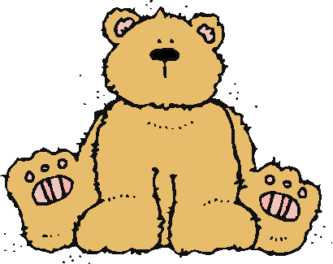 Jr.K Chronicle 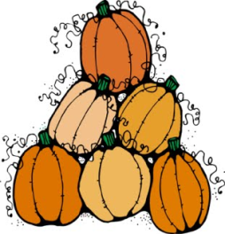

Week of 10/24 |  | WEEKLY NEWSLETTER
Subjects | What We Will Be Doing | Notes/Reminders
Math  Reading  Color of the Week  Writing  Social Studies  Spanish | Number of the Week: Number 7  Stations- tactile numbers, seven to seven correspondences, number game. Identify and sort the number 7. Station- Number 7 game, identify number 7, look around the room. “Play dough Counting” Bone counting. AB pattern head band.  Story time- Pumpkin books, Franklin Afraid of the Dark, Skeleton (the different bones in the body), There is Monster in my Closet, Monster Spray, There is an Alligator Under my Bed. (nightmare unit)  Gray– List items that are gray. Identify objects around the room that are gray. Color an item that is gray. Station- sorting, identifying, and painting things that are gray. Frog Street press- Sing and Read about gray.  Practice name writing. Handwriting without tears identifying letters and numbers. Begin writing numbers (always start at the top)  Calendar, Days of the Week, and Months of the Year.  Days of the Week, Months of the Year, and Color of the Week. Parts of the body. For example, eyes-ojos. Colors of the rainbow. How to greet and say goodbye. | PLEASE REMEMBER TO FILL OUT VOLUNTEER SHEET IF YOU MADE PLAY DOUGH AND PLEASE PUT IT IN THEIR STAR FOLDERS FOR ME TO SIGN. THANK YOU  NOTE: SAME FOR CLASSROOM VOLUNTEER WORK  Important Upcoming dates:  *October 28th- Fall Harvest Celebration and costume parade.  *Early Dismissal October 28th Day - 8:00am-11:30am  *November 4th- Field Trip to Straw Hat Pizza/Early Dismissal.  *Please sign the field trip form and return by Wednesday October 26th. Surprise box is in alphabetical order. A reminder that the homework (scarecrow family project is due on November 1st.
Art/Theatre | Bats, stamping, AB pattern headband (spider and pumpkins) Play dough cookie cutters, and Fall Harvest celebration stations.

