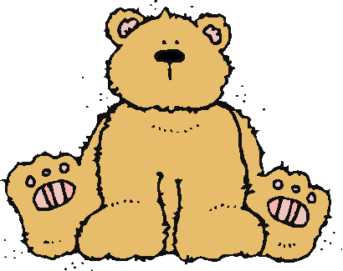 Jr.K Chronicle 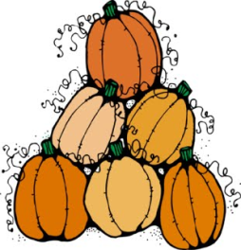

Week of 10/17 |  | WEEKLY NEWSLETTER
Subjects | What We Will Be Doing | Notes/Reminders
Math  Reading  Color of the Week  Writing  Social Studies  Spanish | Number of the Week: Number 6  Stations- tactile numbers, six to six correspondences, number game. Identify and sort the number 6. Station- Number 6 game, identify number 6, look around the room. “Play dough Counting”  AB Pattern with stamping. Haunted house math game.  Story time- Pumpkin books, Where the Wild Things, Skeleton (the different bones in the body), and Five Little Pumpkins.  Black– List items that are black. Identify objects around the room that are black. Color an item that is black. Station- sorting, identifying, and painting things that are black. Frog Street press- Sing and Read about black.  Practice name writing. Handwriting without tears identifying letters and numbers. Begin writing numbers (always start at the top)  Calendar, Days of the Week, and Months of the Year.  Days of the Week, Months of the Year, and Color of the Week. Parts of the body. For example, eyes-ojos. Colors of the rainbow. How to greet and say goodbye. | PLEASE REMEMBER TO FILL OUT VOLUNTEER SHEET IF YOU MADE PLAY DOUGH AND PLEASE PUT IT IN THEIR STAR FOLDERS FOR ME TO SIGN. THANK YOU  NOTE: SAME FOR CLASSROOM VOLUNTEER WORK  Important Upcoming dates:  *October 28th- Fall Harvest Celebration and costume parade.  *Early Dismissal Day- 8:00am-11:30am  *We will be starting Surprise Box this week and I will be sending home a family scarecrow project.
Art/Theatre | Where the Wild Things Are-masks, Spider on the Floor, One Little Skeleton, Tactile 6, Fall art stain glass.

