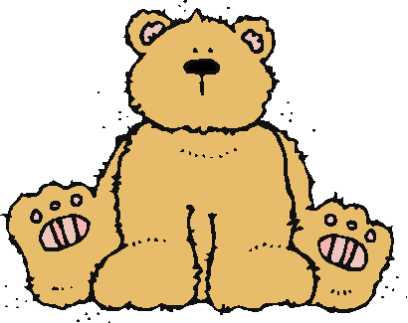 Jr.K Chronicle 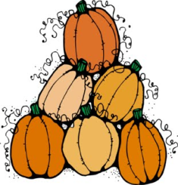

Week of 10/10 |  | WEEKLY NEWSLETTER
Subjects | What We Will Be Doing | Notes/Reminders
Math  Reading  Color of the Week  Writing  Social Studies  Spanish | Number of the Week: Number 5  Stations- tactile numbers, five to four correspondences, number game. Identify and sort the number 5. Station- Number 5 game, identify number 5, look around the room. “Play dough Counting”  AB Pattern. What is it? How do you make it? Cookie- count and put 5 chocolate chips on the cookie.  Story time- Pumpkin books, Teddy Bear Teddy Bear, Brown Bear Brown Beat, read to your bear. Teddy Bear Picnic!  Pink– List items that are brown. Identify objects around the room that are brown. Color an item that is brown. Station- sorting, identifying, and painting things that are brown. Frog Street press- Sing and Read about brown.  Practice name writing. Handwriting without tears identifying letters and numbers. Begin writing numbers (always start at the top)  Calendar, Days of the Week, and Months of the Year.  Days of the Week, Months of the Year, and Color of the Week. Parts of the body. For example, eyes-ojos. Colors of the rainbow. How to greet and say goodbye. | PLEASE REMEMBER TO FILL OUT VOLUNTEER SHEET IF YOU MADE PLAY DOUGH AND PLEASE PUT IT IN THEIR STAR FOLDERS FOR ME TO SIGN. THANK YOU  NOTE: SAME FOR CLASSROOM VOLUNTEER WORK  Important Upcoming dates:  *October 11th- Picture Day  *October 14th- Junior Kindergarten Teddy Bear Picnic! (Please see invitation on weebly)  *Please remember to bring teddy bears on Tuesday or Wednesday for the teddy bear slumber party!
Art/Theatre | Teddy Bear-role play. Pumpkin handprint art project. Bear headbands. Pictures with bear for picnic!

