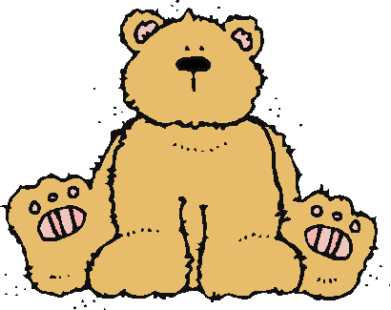 Jr.K Chronicle 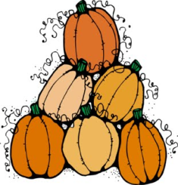

Week of 10/3 |  | WEEKLY NEWSLETTER
Subjects | What We Will Be Doing | Notes/Reminders
Math  Reading  Color of the Week  Writing  Social Studies  Spanish | Number of the Week: Number 4  Stations- tactile numbers, four to four correspondences, number game. Identify and sort the number 4. Station- Number 4 game, identify number 4, look around the room. “Play dough Counting”  Sequencing- how to make a jack –o- lantern. Pumpkin matching.  Story time- Pumpkin books, Scat the Cat (finish) Three Little Bears.  Pink– List items that are pink. Identify objects around the room that are pink. Color an item that is pink. Station- sorting, identifying, painting and mixing red and white to make pink. Frog Street press- sing and read about pink.  Practice name writing. Handwriting without tears identifying letters and numbers. Begin writing numbers (always start at the top)  Calendar, Days of the Week, and Months of the Year.  Days of the Week, Months of the Year, and Color of the Week. Parts of the body. For example, eyes-ojos. Colors of the rainbow. How to greet and say goodbye. | PLEASE REMEMBER TO FILL OUT VOLUNTEER SHEET IF YOU MADE PLAY DOUGH AND PLEASE PUT IT IN THEIR STAR FOLDERS FOR ME TO SIGN. THANK YOU  NOTE: SAME FOR CLASSROOM VOLUNTEER WORK  First Week of October! This Friday is AM schedule class will be held from 8:00am-11:30am!  Important Upcoming dates:  *October 7th- Early day-class will be from 8:00am-11:30am  October 11th- Picture Day  October 14th- Junior Kindergarten Teddy Bear Picnic! (Please see invitation on weebly soon)
Art/Theatre | Little Miss Muffet-role play. The Three Little Bears story- act out story with props. Bear Hunt Song.

