Jr.K Chronicle 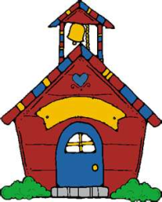

Week of 9/05 |  | WEEKLY NEWSLETTER
Subjects | What We Will Be Doing | Notes/Reminders
Math  Reading  Color of the Week  Writing  Social Studies  Spanish | Number of the Week: Number 2  Stations- tactile numbers, two to two correspondences, number game. Identify and sort the number 2. Station- Number 2 game, identify number 2, look around the room.  Story time- Fire safety books, number books, color books. Reading Station – Library, rhyming words.  Green– List items that are green. Identify objects around the room that are green. Color an item that is green. Station- sorting, identifying, painting and mixing colors.  Begin Handwriting Without Tears-Station- building a letter. Big curve little curve, big line small line. Trace letters, use sandpaper. “Pencil pickups”  Calendar, Days of the Week, and Months of the Year.  Days of the Week, Months of the Year, and Color of the Week. Parts of the body. For example, eyes-ojos. | PLEASE REMEMBER TO FILL OUT VOLUNTEER SHEET IF YOU MADE PLAY DOUGH AND PLEASE PUT IT IN THEIR STAR FOLDERS FOR ME TO SIGN. THANK YOU  NOTE: SAME FOR CLASSROOM VOLUNTEER WORK  Important Upcoming dates:  September 28th- Fire drill  October 7th- Early day-class will be from 8:00am-11:30am  October 11th- Picture Day
Art/Theatre | Thumbprint hand apple tree project, Apple wish, make stars, dot to dot bingo markers picture, Star project. Role play- Twinkle Twinkle

