Jr.K Chronicle 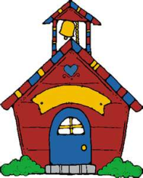

Week of 9/05 |  | WEEKLY NEWSLETTER
Subjects | What We Will Be Doing | Notes/Reminders
Math  Reading  Color of the Week  Writing  Social Studies  Spanish | Number of the Week: Number 1  Stations- tactile numbers, one to one correspondence, number game. Identify and sort the number 1. Station- Create over to shape book.  Story time- Bubbles Bubbles, number books, Humpty Dumpty, color books. Reading Station - Library  Blue– List items that are blue. Identify objects around the room that are blue. Color an item that is blue. Station- sorting, identifying, painting and mixing colors.  Begin Handwriting Without Tears-Station- building a letter. Big curve little curve, big line small line.  Calendar, Days of the Week, and Months of the Year.  Days of the Week, Months of the Year, and Color of the Week. Parts of the body. For example, eyes-ojos. | PLEASE REMEMBER TO FILL OUT VOLUNTEER SHEET IF YOU MADE PLAY DOUGH AND PLEASE PUT IT IN THEIR STAR FOLDERS FOR ME TO SIGN. THANK YOU  NOTE: SAME FOR CLASSROOM VOLUNTEER WORK  Fun Friday Stations- Starry Apple Surprise (star apple story), bingo stamps picture, play dough, kitchen, exploration, and bubbles bubbles project.
Art/Theatre | Apple tear project, starry surprise, bubbles bubbles, bingo markers picture. Role play- Humpty Dumpty

