Jr.K Chronicle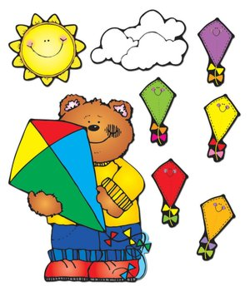

Week of 3/25 |  | WEEKLY NEWSLETTER
Subjects | What We Will Be Doing | Notes/Reminders
Math  Reading/Language Arts  Letter of the Week  Writing  Social Studies  Spanish  Science | Guesstimate. Learning how to guesstimate and count out which has more and which has less. Sorting and counting out manipulatives higher than 20. Measuring different sized items and sorting from biggest to smallest.  Story time- Springtime books. Kites and Spring weather. Station- Library/ Partner reading. Learn alphabet in sign language.  Letter of the Week: “L”. What begins with the letter “l”, what sounds it makes, how to write the letter “l?” Use picture and letter cards. Create a letter book. Introduce letter “M” Review letters learned.  Practice name writing. Handwriting without tears identifying letters and numbers. Begin writing numbers 0-21. Write letters. Begin learning how to write and learn high frequency words. Creative writing-station. Story and picture writing.  Calendar, Days of the Week, and Months of the Year. Calendar. Introduce March. Spring break.  Days of the Week, Months of the Year, and Color of the Week. Parts of the body. For example, eyes-ojos. Colors of the rainbow. How to greet and say goodbye. Please and thank you. Animals.  Weather. Discuss the weather. Nature. Learn about Spring weather. Plant life. Animals. | PLEASE REMEMBER TO FILL OUT VOLUNTEER SHEETS FOR ME TO SIGN.  *Then I will submit them to the front desk to be recorded.  Important Upcoming dates:  *March 26rd- Original Art Works orders are due!  *March 30th- Early Day! Spring Performance with other grades at 11:00am-11:30am  *Spring Break- April 2-13  Return on April 16th!  *New Star of the Week!  *Surprise box is in alphabetical order.
Art/Theatre | How to be a good friend. Friendship circle. Spring time projects. Bunny and baby chick project. Flower project. Creative play and role play. Practice Spring performance songs! Rehearsal for Spring performance.

