Jr.K Chronicle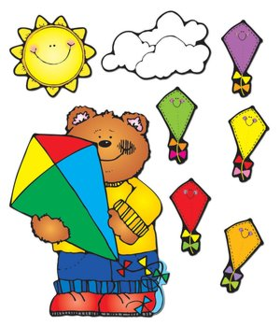

Week of 3/12 |  | WEEKLY NEWSLETTER
Subjects | What We Will Be Doing | Notes/Reminders
Math  Reading/Language Arts  Letter of the Week  Writing  Social Studies  Spanish  Science | Number of the Week: Potato math game. Numbers 0 to 20  Stations- Identify and sort the numbers 0 to 20 with gold coins. Math game whiteboards. Writing numbers 0-20. Sorting out manipulatives and counting which has more and less.  Story time- Leprechaun/ St. Patrick’s Day books. Station- Library/ Partner reading. Learn alphabet in sign language.  Letter of the Week: “K”. What begins with the letter “k”, what sounds it makes, how to write the letter “k?” Use picture and letter cards. Create a letter book. Introduce letter “J” Review letters learned.  Practice name writing. Handwriting without tears identifying letters and numbers. Begin writing numbers 0-21. Write letters. Begin learning how to write and learn high frequency words. Creative writing-station. Leprechaun writing story. Dictating creative stories.  Calendar, Days of the Week, and Months of the Year. Calendar. Introduce March. St. Patrick’s Day.  Days of the Week, Months of the Year, and Color of the Week. Parts of the body. For example, eyes-ojos. Colors of the rainbow. How to greet and say goodbye. Please and thank you. Animals.  Weather. Discuss the weather. Nature. Learn about Spring. Animals. | PLEASE REMEMBER TO FILL OUT VOLUNTEER SHEETS FOR ME TO SIGN.  *Then I will submit them to the front desk to be recorded.  Important Upcoming dates:  *March 15th- Wear Green! Leprechaun Day!!!!  *March 16th- No school  *March 30th- Early Day! Spring Performance with other grades at 11:00am-11:30am  *New Star of the Week!  *Surprise box is in alphabetical order.
Art/Theatre | How to be a good friend. Friendship circle. Four leaf clover. Leprechauns. Rainbow painting. Leprechaun findings page. Leprechaun art project. Creative play and role play. Practice Spring performance songs!

