Jr.K Chronicle 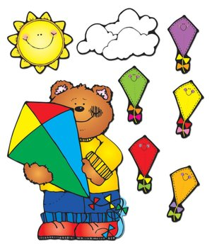

Week of 2/26 |  | WEEKLY NEWSLETTER
Subjects | What We Will Be Doing | Notes/Reminders
Math  Reading/Language Arts  Letter of the Week  Writing  Social Studies  Spanish  Science | Number of the Week: Dr. Seuss Math Game. Numbers0 to 20  Stations- Identify and sort the numbers 0 to 20. Math game whiteboards. Writing numbers 0-20. Graphing conversation hearts by color. Sorting them and counting which has more and less.  Story time- Dr. Seuss Week! Dr. Seuss books. Station- Library/ Partner reading. Learn alphabet in sign language. Dr. Seuss rhyming. Rhyming circle and Dr. Seuss rhyming game.  Letter of the Week: “I”. What begins with the letter “I”, what sounds it makes, how I write the letter “i?” Use picture and letter cards. Create a letter book. Introduce letter “H.” Review letter learned.  Practice name writing. Handwriting without tears identifying letters and numbers. Begin writing numbers 0-21. Write letters.  Calendar, Days of the Week, and Months of the Year. Calendar. Introduce March. St. Patrick’s Day.  Days of the Week, Months of the Year, and Color of the Week. Parts of the body. For example, eyes-ojos. Colors of the rainbow. How to greet and say goodbye. Please and thank you.  Weather. Discuss the weather. Nature. Learn about Spring. Animals. | PLEASE REMEMBER TO FILL OUT VOLUNTEER SHEETS FOR ME TO SIGN.  *Then I will submit them to the front desk to be recorded.  Important Upcoming dates:  *March 2nd- Early Day/ Dr. Seuss’s Birthday!  *March 2nd- Books and Blankets 6-8pm  *March 16th- No school  *March 30th- Early Day  *Star of the Week  *Surprise box is in alphabetical order.
Art/Theatre | How to be a good friend. Friendship circle. Shamrocks. Dr. Seuss projects. The Lorax, Cat in the Hat, Dr. Seuss create your own project. Acting out Dr. Seuss stories.

