Jr.K Chronicle 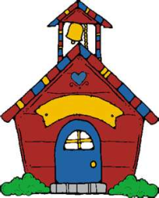

Week of 9/05 |  | WEEKLY NEWSLETTER
Subjects | What We Will Be Doing | Notes/Reminders
Math  Reading  Color of the Week  Writing  Social Studies  Spanish | Identify, sort, and classify rectangle objects and be able to identify shapes that do not belong.  “Ricky Rectangle”- poem  What is a rectangle? Books and discussion on what makes a rectangle. Station-rectangles  Story time, story of heroes for 9/11.  Reading Station - Library  Yellow – List items that are yellow. Identify objects around the room that are yellow. Color an item that is yellow. Station- sorting, identifying, and painting.  Begin Handwriting Without Tears-Station- building a letter. Magic “C”  Calendar, Days of the Week, and Months of the Year. Station- 9/11- Heroes, book and art project honoring the heroes of 9/11.  Days of the Week, Months of the Year, and Color of the Week. | NO SCHOOL ON SEPTEMBER 5th – Labor Day  *All on A.M. schedule this Friday 9/09 school hours- 8:00am-11:30am!  Honoring Heroes- for 9/11 What is a hero? Who are heroes? Special art project on this Friday 9/09  PLEASE REMEMBER TO FILL OUT VOLUNTEER SHEET IF YOU MADE PLAY DOUGH AND PLEASE PUT IT IN THEIR STAR FOLDERS FOR ME TO SIGN. THANK YOU  NOTE: SAME FOR CLASSROOM VOLUNTEER WORK

