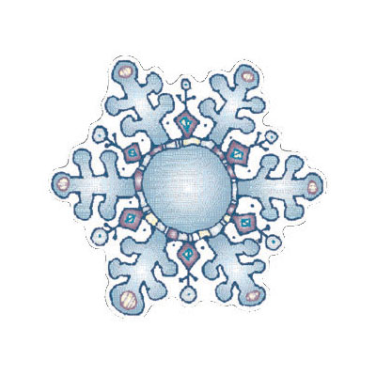Jr.K Chronicle 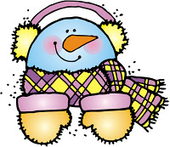

Week of 1/9 |  | WEEKLY NEWSLETTER
Subjects | What We Will Be Doing | Notes/Reminders
Math  Reading  Letter of the Week  Writing  Social Studies  Spanish  Science | Number of the Week: Number 15  Stations- tactile numbers, fifteen to fifteen correspondences, number game. Identify and sort the number 15. Station- Number 15 game, identify number 15, look around the room. My 10 Best Friends. Connect the numbers. Assessment-counting and identifying numbers from 1-10, names/identifying shapes, sorting and counting manipulatives, etc.  Story time- Winter books. Snowman and Penguin books. Review Letter “C” book/”E”. Station- Library. Assessment- Can they identify the title of the book/ tracking from left to right.  Letter of the Week: “C”. What begins with the letter “c”, what sounds it makes, how I write the letter “c?” Use picture and letter cards. Introduce letter “E.”  Practice name writing. Handwriting without tears identifying letters and numbers. Begin writing numbers (always start at the top). Writing the color words. Assessment- writing their names (do they use a capital? Lowercase?) Identify color words.  Calendar, Days of the Week, and Months of the Year. Calendar. Assessment- can you tell me the days of the week? Months of the year?  Days of the Week, Months of the Year, and Color of the Week. Parts of the body. For example, eyes-ojos. Colors of the rainbow. How to greet and say goodbye. Please and thank you.  Winter Weather. What makes snow? What makes snowflakes? What does snow look like? Graph weather for the week. | PLEASE REMEMBER TO FILL OUT VOLUNTEER SHEETS FOR ME TO SIGN.  *Then I will submit them to the front desk to be recorded.  Important Upcoming dates:  *January 9th-13th- Assessing the students during class time.  *January 16th- No school. Martin Luther King Day.  *January 23rd-27th- Parent Teacher Conferences! Please remember to sign up on the Google Document!  *Surprise box is in alphabetical order.
Art/Theatre | Snowman art project. Snowflake stamp. Snowflake project. Act out stories. How to be a good friend/ act out different scenarios.

