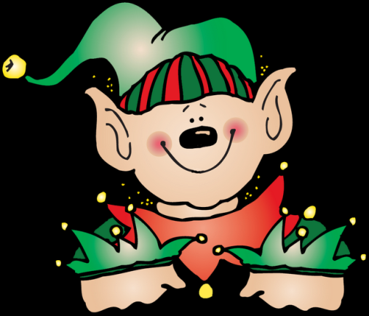 Jr.K Chronicle 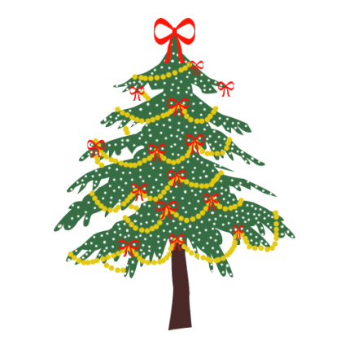

Week of 12/11 |  | WEEKLY NEWSLETTER
Subjects | What We Will Be Doing | Notes/Reminders
Math  Reading  Color of the Week  Writing  Social Studies  Spanish  Science | Number of the Week: Number 13  Stations- tactile numbers, thirteen to thirteen correspondences, number game. Identify and sort the number 13. Station- Number 13 game, identify number 13, look around the room. My 10 Best Friends. Writing numbers. Review numbers 1-10. Connect the numbers.  Story time- Winter books and weather books. Christmas books. Gingerbread Baby. Station- Library  Review of all the colors we have learned. Sing and Read all songs we have learned. Practice recognizing/writing the colors. Frog Street press- Sing and Read all songs.  Practice name writing. Handwriting without tears identifying letters and numbers. Begin writing numbers (always start at the top). Writing the color words.  Calendar, Days of the Week, and Months of the Year. Calendar.  Days of the Week, Months of the Year, and Color of the Week. Parts of the body. For example, eyes-ojos. Colors of the rainbow. How to greet and say goodbye. Please and thank you.  Weather. Review of the four seasons. Winter. Graph weather for the week. | PLEASE REMEMBER TO FILL OUT VOLUNTEER SHEETS FOR ME TO SIGN.  *Then I will submit them to the front desk to be recorded.  Important Upcoming dates:  *December 16th- Last day of school for Winter Break.  *Winter Break-December 19th-January 3rd  *Surprise box is in alphabetical order.
Art/Theatre | Pinecone trees. Finish reindeer project. Gingerbread baby house. Painting snow pictures.

