Jr.K Chronicle 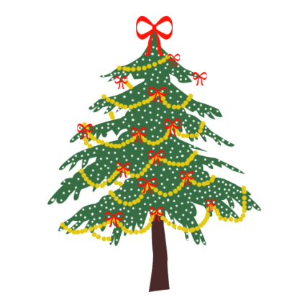

Week of 12/5 |  | WEEKLY NEWSLETTER
Subjects | What We Will Be Doing | Notes/Reminders
Math  Reading  Color of the Week  Writing  Social Studies  Spanish  Science | Number of the Week: Number 12  Stations- tactile numbers, twelve to twelve correspondences, number game. Identify and sort the number 12. Station- Number 12 game, identify number 12, look around the room. My 10 Best Friends. Writing numbers. Review numbers 1-10. Gingerbread man math.  Story time- Winter books and weather books. Christmas books. Station- Library  Review of all the colors we have learned. Sing and Read all songs we have learned. Practice recognizing/writing the colors. Frog Street press- Sing and Read about orange.  Practice name writing. Handwriting without tears identifying letters and numbers. Begin writing numbers (always start at the top). Writing the color words.  Calendar, Days of the Week, and Months of the Year. Calendar.  Days of the Week, Months of the Year, and Color of the Week. Parts of the body. For example, eyes-ojos. Colors of the rainbow. How to greet and say goodbye. Please and thank you.  Seasons. What are the four seasons? What kind of weather helps us know what season it is? What happens to the trees? Winter season. How we know it is winter. Types of trees. | PLEASE REMEMBER TO FILL OUT VOLUNTEER SHEETS FOR ME TO SIGN.  *Then I will submit them to the front desk to be recorded.  Important Upcoming dates:  *December 10th- Winter Festival  *Winter Break-December 19th-January 3rd  *Surprise box is in alphabetical order.
Art/Theatre | Winter trees. Handprint tree. Free painting.

