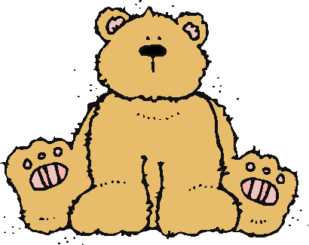 Jr.K Chronicle 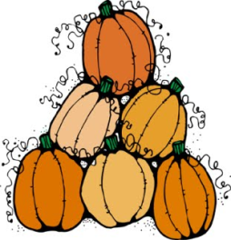

Week of 11/28 |  | WEEKLY NEWSLETTER
Subjects | What We Will Be Doing | Notes/Reminders
Math  Reading  Color of the Week  Writing  Social Studies  Spanish  Science | Number of the Week: Number 11  Stations- tactile numbers, eleven to eleven correspondences, number game. Identify and sort the number 11. Station- Number 11 game, identify number 11, look around the room. My 10 Best Friends. Writing numbers. Review numbers 1-10.  Story time- Winter books and weather books. Christmas books. Station- Library  Review of all the colors we have learned. Sing and Read all songs we have learned. Practice recognizing/writing the colors. Frog Street press- Sing and Read about yellow.  Practice name writing. Handwriting without tears identifying letters and numbers. Begin writing numbers (always start at the top) Compare writing from September to November.  Calendar, Days of the Week, and Months of the Year. Calendar.  Days of the Week, Months of the Year, and Color of the Week. Parts of the body. For example, eyes-ojos. Colors of the rainbow. How to greet and say goodbye. Please and thank you.  Seasons. What are the four seasons? What kind of weather helps us know what season it is? What happens to the trees? | PLEASE REMEMBER TO FILL OUT VOLUNTEER SHEETS FOR ME TO SIGN.  Important Upcoming dates:  *November 30th- Fire Drill  * December 2nd- Lockdown Drill  *December 10th- Winter Festival  *Surprise box is in alphabetical order.
Art/Theatre | Winter trees. Introducing the Baby Gingerbread man.

