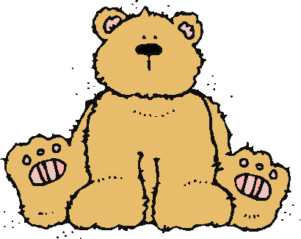 Jr.K Chronicle 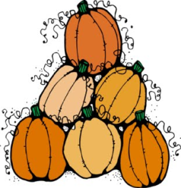

Week of 11/14 |  | WEEKLY NEWSLETTER
Subjects | What We Will Be Doing | Notes/Reminders
Math  Reading  Color of the Week  Writing  Social Studies  Spanish  Science | Number of the Week: Number 10  Stations- tactile numbers, ten to ten correspondences, number game. Identify and sort the number 10. Station- Number 10 game, identify number 10, look around the room. My 10 Best Friends. Writing numbers. Zero the Hero.  Story time- Fall books, Goldilicous, Thanksgiving books, and rain books.  Gold – List items that are gold. Identify objects around the room that are gold. Color an item that is gold. Station- sorting, identifying, and painting things that are gold. Frog Street press- Sing and Read about green.  Practice name writing. Handwriting without tears identifying letters and numbers. Begin writing numbers (always start at the top) Turkey tracks and thinking thankful thoughts.  Calendar, Days of the Week, and Months of the Year. Calendar.  Days of the Week, Months of the Year, and Color of the Week. Parts of the body. For example, eyes-ojos. Colors of the rainbow. How to greet and say goodbye. Please and thank you.  Names of the different type of clouds. What the five senses do for the body. | PLEASE REMEMBER TO FILL OUT VOLUNTEER SHEETS FOR ME TO SIGN.  Important Upcoming dates:  *November 21st-25th Thanksgiving Break  *Surprise box is in alphabetical order.
Art/Theatre | I am thankful for…. Fall leaves, turkey, scarecrow, make a necklace.

