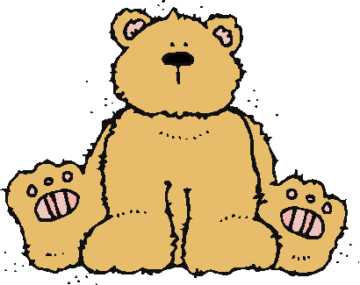 Jr.K Chronicle 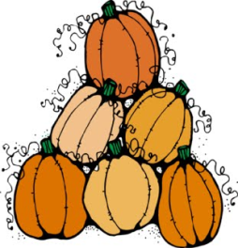

Week of 11/07 |  | WEEKLY NEWSLETTER
Subjects | What We Will Be Doing | Notes/Reminders
Math  Reading  Color of the Week  Writing  Social Studies  Spanish  Science | Number of the Week: Number 9  Stations- tactile numbers, nine to nine correspondences, number game. Identify and sort the number 9. Station- Number 9 game, identify number 9, look around the room. My 10 Best Friends. Writing numbers.  Story time- Spilt Milk. Fruit and Veggie books, 5 Senses (focus on smell and touch), and Fall books. Station- Library  Silver – List items that are silver. Identify objects around the room that are silver. Color an item that is silver. Station- sorting, identifying, and painting things that are silver. Frog Street press- Sing and Read about blue.  Practice name writing. Handwriting without tears identifying letters and numbers. Begin writing numbers (always start at the top)  Calendar, Days of the Week, and Months of the Year. Veteran’s Day.  Days of the Week, Months of the Year, and Color of the Week. Parts of the body. For example, eyes-ojos. Colors of the rainbow. How to greet and say goodbye. Please and thank you.  Names of the different type of clouds. What the five senses do for the body. | PLEASE REMEMBER TO FILL OUT VOLUNTEER SHEETS FOR ME TO SIGN.  Important Upcoming dates:  *November 11th- No school Veteran’s Day  *November 21st-25th Thanksgiving Break  *Surprise box is in alphabetical order.
Art/Theatre | 5 Senses art project (touch). Tactile number 9. Fruit and Veggie felt project. Clouds art project.

