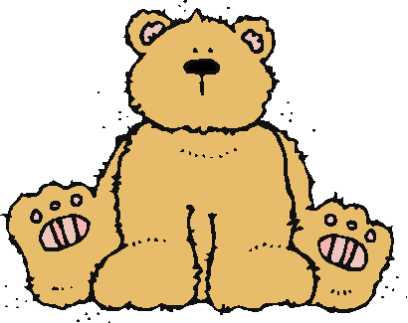 Jr.K Chronicle 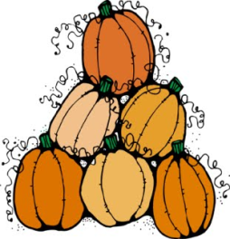

Week of 10/31 |  | WEEKLY NEWSLETTER
Subjects | What We Will Be Doing | Notes/Reminders
Math  Reading  Color of the Week  Writing  Social Studies  Spanish | Number of the Week: Number 8  Stations- tactile numbers, eight to eight correspondences, number game. Identify and sort the number 8. Station- Number 8 game, identify number 8, look around the room. My 10 Best Friends. Writing numbers.  Story time- Bone books, Fruit and Veggie books, 5 Senses, and Fall books. Station- Library  White (blanco) – List items that are white. Identify objects around the room that are white. Color an item that is white. Station- sorting, identifying, and painting things that are white. Frog Street press- Sing and Read about white.  Practice name writing. Handwriting without tears identifying letters and numbers. Begin writing numbers (always start at the top)  Calendar, Days of the Week, and Months of the Year.  Days of the Week, Months of the Year, and Color of the Week. Parts of the body. For example, eyes-ojos. Colors of the rainbow. How to greet and say goodbye. Please and thank you. | PLEASE REMEMBER TO FILL OUT VOLUNTEER SHEET IF YOU MADE PLAY DOUGH AND PLEASE PUT IT IN THEIR STAR FOLDERS FOR ME TO SIGN. THANK YOU  NOTE: SAME FOR CLASSROOM VOLUNTEER WORK  Important Upcoming dates:  *November 4th- Field Trip to Straw Hat Pizza/Early  Dismissal. 8:00am-11:30am  - Field trip at 9:30am  - Assembly at 8:30am  *November 4th- Family Movie Night! Begins at 6:00pm  *Surprise box is in alphabetical order.  *A reminder that the homework (scarecrow family project is due on November 1st.
Art/Theatre | 5 Senses art project. Tactile number 8. Fruit and Veggie felt project.

