Jr.K Chronicle 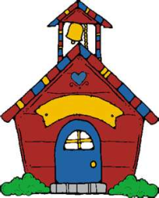

Week of 8/29 |  | WEEKLY NEWSLETTER
Subjects | What We Will Be Doing | Notes/Reminders
Math  Reading  Color of the Week  Writing  Social Studies  Spanish | Identify, sort, and classify square objects and be able to identify shapes that do not belong.  “Sammy Square”- poem  Story time – Corduroy  Reading Station - Library  Orange – List items that are orange. Identify objects around the room that are orange. Color an item that is orange.  Begin Handwriting Without Tears  Calendar, Days of the Week, and Months of the Year. Discuss Labor Day.  Days of the Week, Months of the Year, and Color of the Week. | NO SCHOOL ON SEPTEMBER 1st AND SEPTEMBER 2nd  PLEASE REMEMBER TO FILL OUT VOLUNTEER SHEET IF YOU MADE PLAY DOUGH AND PLEASE PUT IT IN THEIR STAR FOLDERS FOR ME TO SIGN. THANK YOU  NOTE: SAME FOR CLASSROOM VOLUNTEER WORK

